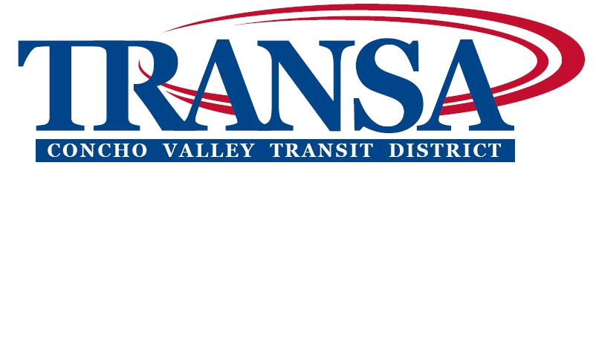

NOTICE OF A PUBLIC MEETING
CONCHO VALLEY TRANSIT DISTRICT

2:40 P.M.
WEDNESDAY, MARCH 16, 2016
Concho Valley Regional Conference and Training Center
2801 W. Loop 306, Suite A., San Angelo, TX 76904

The meeting place is accessible to persons with disabilities. If assistance is needed to observe or comment, please call the Council office at 944-9666 at least 24 hours prior to the meeting.

BUSINESS

- DETERMINATION OF QUORUM AND CALL TO ORDER

- INVOCATION & PLEDGE OF ALLEGIENCE

- APPROVAL OF MINUTES of February 10, 2016 meeting (See Attachment A)

- PRESENTATION, REVIEW, & APPROVAL of Resolution 031616A accepting the CVTD Annual Financial Audit for FY 14-15 (Attachment B will be sent via email and copies will be distributed at the meeting)

- APPROVAL OF CHECKS over $2,000 written since last meeting (See Attachment C)

- REVIEW & APPROVAL of Resolution 031616B accepting the CVTD Title VI Program Policy & ADA Para-Transit Plan/Revised 2-2016 (See Attachment D)

- REVIEW & APPROVAL of Resolution 031616C supporting a request to award contract for ADA Compliant Restroom & Kitchen area for the CVTD Multimodal Shell Building (See Attachment E)

- REVIEW & APPROVAL of Resolution 031616D supporting a request to award contract for a Fire Suppression System for the CVTD Multimodal Shell Building/Not to exceed $30,000 (See Attachment F)

- REVIEW & APPROVAL of Resolution 031616E supporting a request to award contract for flooring at the CVTD Multimodal Shell Building/Not to exceed $30,000 (See Attachment G)

- REVIEW Financial Reports/Balance Sheet – December 2015(See Attachment H)

- CVTD General Manager’s Report – Vince Huerta

- OTHER Discussion Items or Future Agenda Items

- ADJOURN

Posted in accordance with the Texas Government Code, Title V, Chapter 551, Section .053, this Thursday, March 10, 2016.

John Austin Stokes, Executive Director

